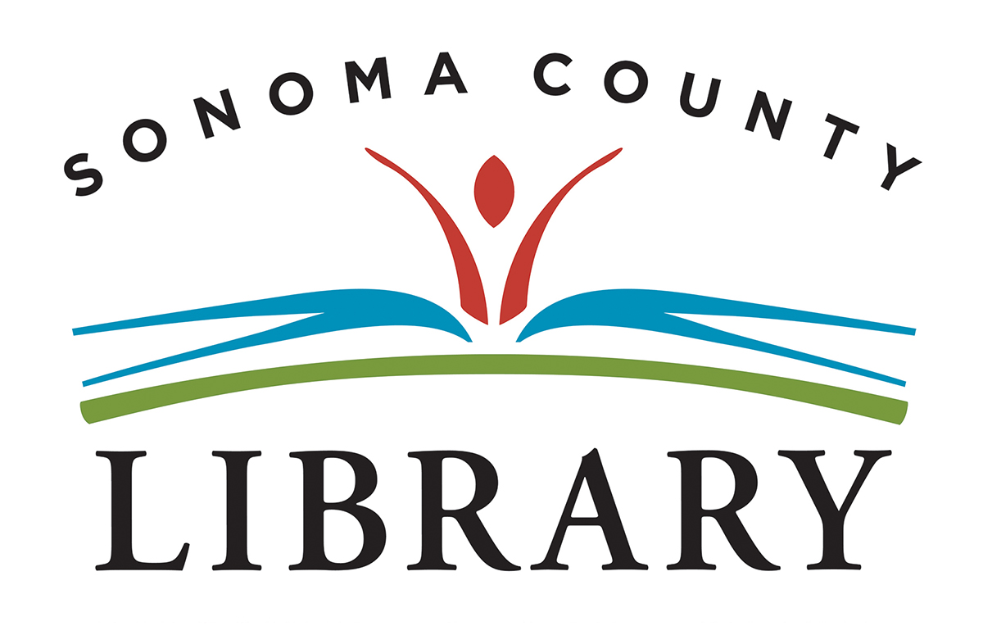

**Resolution in Support of Undocumented Residents/Immigrants/Dreamers**

Whereas, American society is one composed of immigrants, entering our country at different times, encompassing people of diverse origins, ages, backgrounds, views and cultures, and contributing strong, valuable elements in the social fabric of our communities, states, and nation;

Whereas, in June 2012, President Barack Obama established Deferred Action for Childhood Arrivals (DACA), for immigrants who came to the United States as children (Dreamers), and created the opportunity to apply for temporary residence and eligibility for a work permit in the United States, thus, providing safety until immigration issues could be resolved;

Whereas, Sonoma County has between 25,000-40,000 undocumented immigrants living inside its boundaries with approximately 6000 eligible for the Deferred Action for Childhood Arrivals (DACA) program;

Whereas, the health and safety of these residents of Sonoma County are now threatened due to the actions of the President of the United States and U.S. Immigration and Customs Enforcement;

Whereas, on October 5th of 2017, the California State Governor, Jerry Brown, signed SB54 declaring California a Sanctuary State;

Whereas, the County of Sonoma has declared its support of Dreamers and undocumented immigrants, who have come to our community to build a better life and are now part of our community;

Whereas, the leadership of the American Library Association, the California Library Association, the State of California, and the County of Sonoma have expressed support for safety and security of all students and community members regardless of residency status;

Whereas, the Sonoma County Library supports the efforts of Sonoma County, the State of California, and others to provide protection for DACA participants and immigrant communities throughout Sonoma County, the State of California, and the nation as a whole;

Whereas, the Sonoma County Library affirms that equity, diversity, and inclusion are core values of democracy and intellectual freedom;

Whereas, Sonoma County Library recognizes the vital need for access to library and information, resources, services, and technologies by all members of the community, especially those who may experience barriers in education, employment and/or housing or other barriers such as in language/literacy, economic, cultural/social, physical/attitudinal, racism, or discrimination based on appearance, ethnicity, immigrant status, housing status, religious background, sexual orientation, gender identity, and/or gender expression;

Whereas, Sonoma County Library provides a safe, respectful space, a central point for community engagement and learning, while addressing issues of marginalization and underrepresentation; and

Whereas, Sonoma County Library serves all community members, regardless of residency status, in building and transforming our community, opening minds, and promoting inclusion and diversity.

Now, therefore, be it *Resolved,* that the Sonoma County Library (SCL):

1. Reaffirms its own “Statement of Inclusivity” “in light of the uncertainty many feel in our current society”;

2. Commits to enacting policies and programs recognizing the diversity of our community and furthering the inclusion of all residents living in Sonoma County;

3. Supports DACA Dreamers and our immigrant community, providing services to all County residents regardless of residency status;

4. Provides the resources to information on legal assistance/guidance extended by the County and other agencies within the County and State to undocumented students, immigrants, and their families;

5. Continues Sonoma County Library policy of protecting the privacy of our

patrons/customers by refusing to release any information regarding personal living situation, collections usage, or other information that might indicate the legal status regarding the documentation of students, families, and/or individuals, including allowing access to Library databases, permitting a search of any library branch or rural station, or responding to information requests by U.S. Immigration and Customs Enforcement or others, unless the appropriate legal request and documents are presented;

6. Urges Congress to pass comprehensive immigration reform to resolve the confounding

issues around immigration; and

7. Encourages all residents to use the library regardless of documented status.

Adopted by the Sonoma County Library Commission

June 4, 2018